Open Arduino IDE and Connect Arduino to computer.
Open File > Examples > 11. ArduinoISP > ArduinoISP
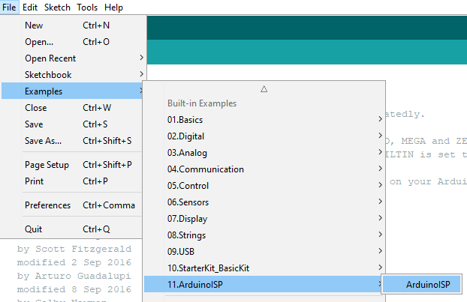
Choose Board : Arduino Uno and Port COM
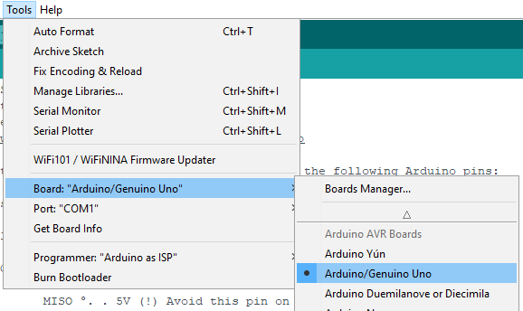
Upload to Arduino Uno
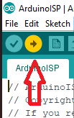

After upload done
Change Board : Arduino Mega 2560 and Processor : ATmega2560
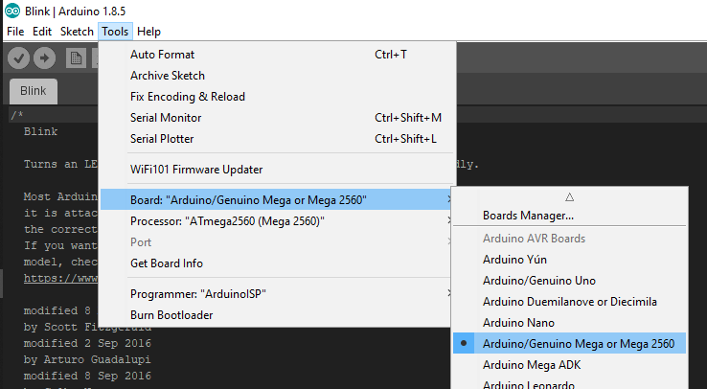
We use pin 10,11,12,13 (SS,MOSI,MISO,CLK) on Arduino Uno
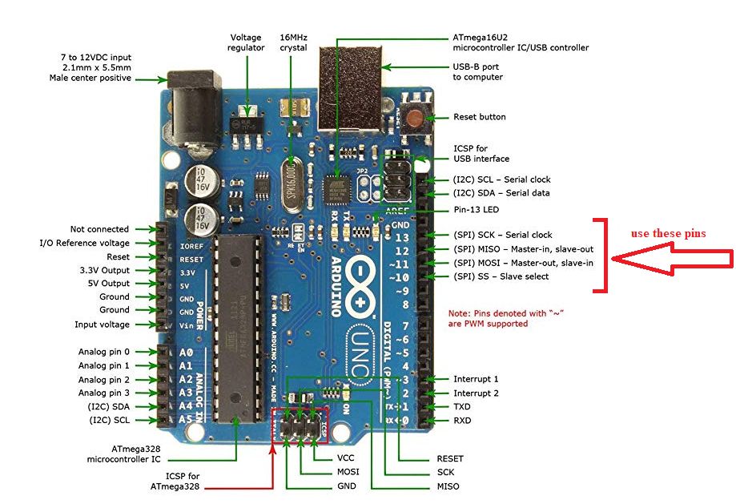

And connect to pins (ISP Port) on the Sensor Node
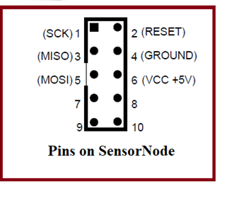
Connect pin on Arduino Uno to Sensor Node
MOSI ( pin 11 ) > MOSI
MISO ( pin12 ) > MISO
SCK ( pin 13 ) > SCK
SS ( pin 10 ) > RESET
VCC ( 5V ) > VCC
GND > GND

Choose Board : Arduino Mega 2560 and Processor : ATmega2560


Connect Arduino to computer
Choose Programmer : “Arduino as ISP” and Port COM

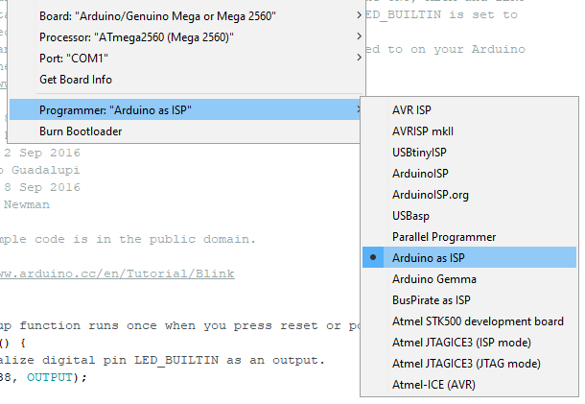
Then click Burn Bootloader for ATmega2560 on Sensor Node.
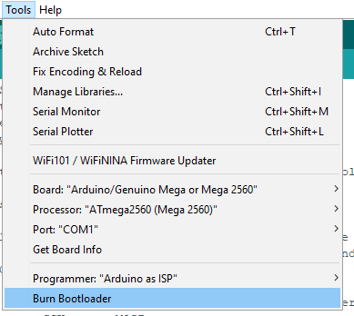
Wait about 30 seconds to finish

Then, Open Aruidno IDE and open (code).ino file (updated code).

You must remove ATMega328P on Arduino UNO,
be careful, foot of Atmega328 can be broken.
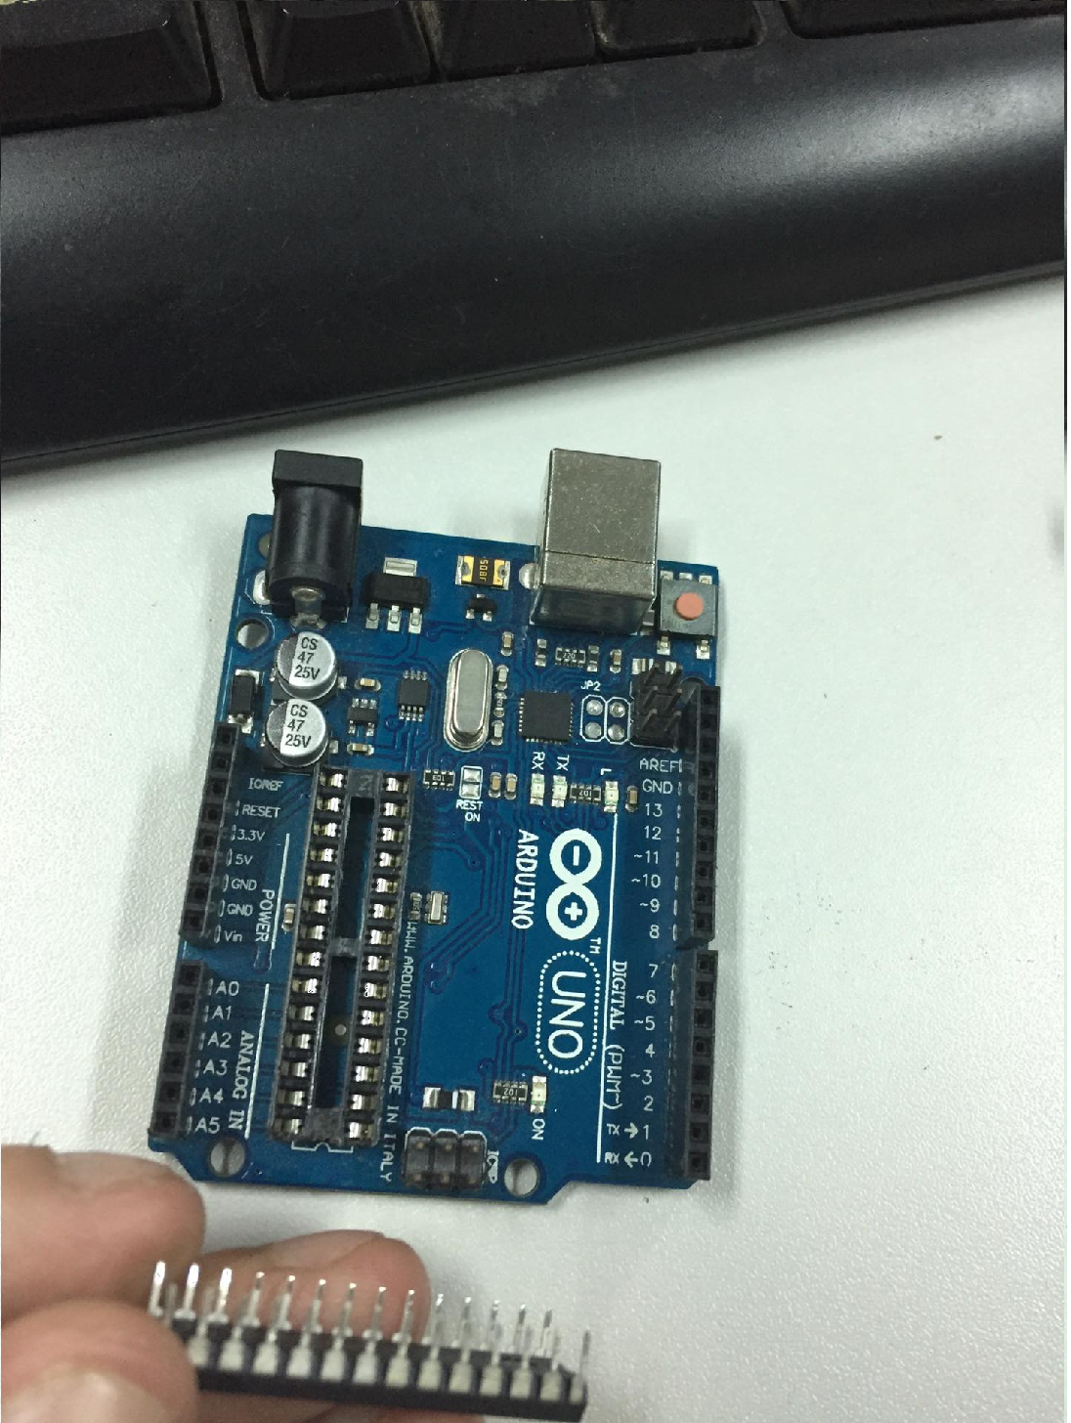

We use the this Arduino Board without Atmega328P

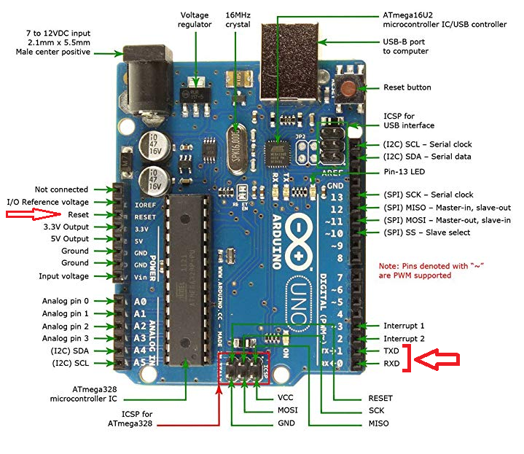
Connect UART pins to SensorNODE. Look 3 pins below the ISP Port.
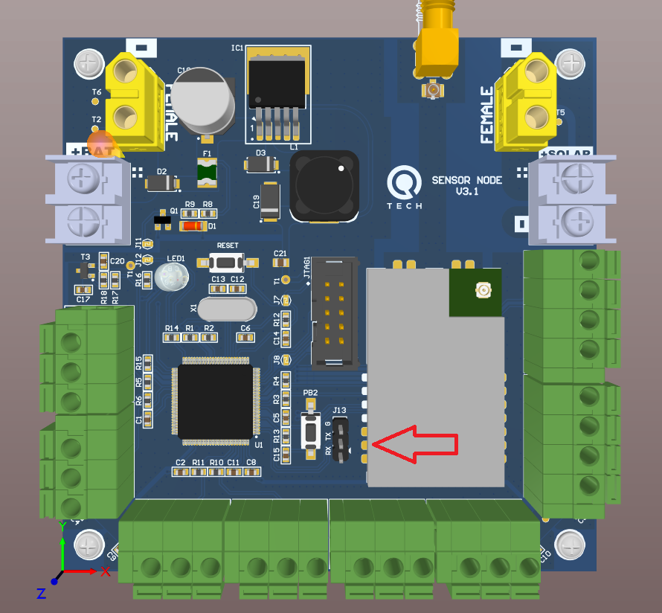

TX > RX
RX > TX
GND > GND
RESET > RESET (on ISP Port)
5V > 5V (on ISP Port)
Then Upload code to ATMega2560 on SensorNode
